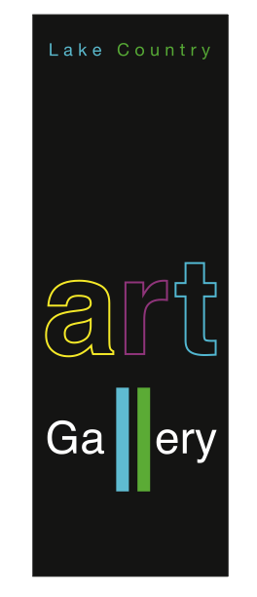
Lake Country Art Gallery

Under 100 Exhibition

Submissions for the Under 100 Exhibition are juried.
The Under 100 Exhibition serves as a fundraiser for the Art Gallery; 30% of sales support the Art Gallery’s programs for the following year.

FORMAT FOR 2018 Please READ INSTRUCTIONS CAREFULLY

How it Works:

Step 1: Submission of intent to participate, deadline September 30.
- You tell us about you and your work using the form provided on www.lakecountryartgallery.ca and then send three sample images by email to show us the type & quality of work that you intend to submit for exhibition.

Step 2: We send you an email specifying how many works you can enter for the opening selection**

Step 3: Invited artists enter Label & Inventory information online for the opening selection* of artworks by November 10th at 6 pm.
- We use this file information to create labels ready for the delivery of your work.
- You deliver your opening selection of art to the Gallery between 11:00 am - 3:00 pm on one of these three days: Thursday Nov 15; Friday Nov 16; Saturday Nov 17

Step 4: As your work sells we will send invitations for you to submit more work on the following Wednesday throughout the exhibition.

